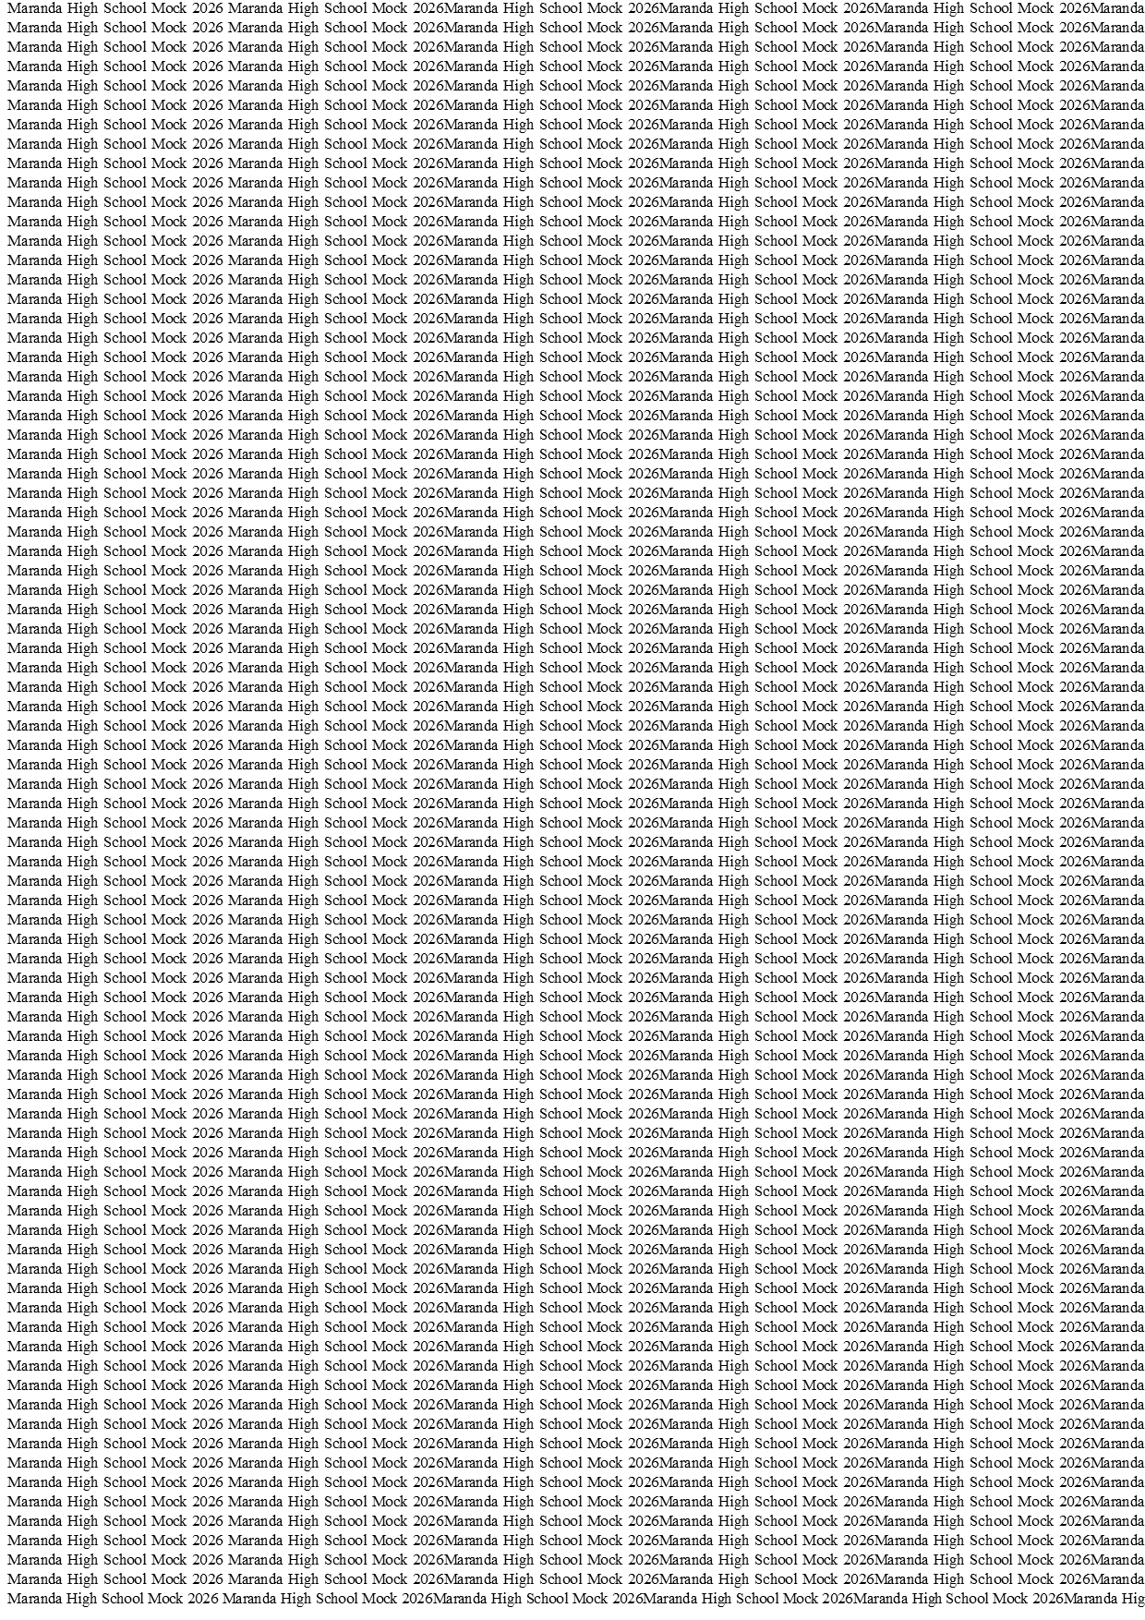



MARANDA HIGH SCHOOL
Kenya Certificate of Secondary Education
THE MOCK EXAMINATIONS, 2026
101/1 ENGLISH PAPER 1

June 2026 Time: 2 Hours

Name: …………………………………….……. Admission No: …………
Stream: ………………. Signature: ………......... Monday, 10th June, 2026; 2:00-4.30pm
Instructions
- Write your name, admission number, stream and signature in the spaces provided above
- All answers must be written in the spaces provided in this question paper
- This paper consists of 9 printed pages with 3 sections
- Candidate should check the question paper to ascertain that all the pages are printed as indicated and that no questions are missing
- Candidates should answer the questions in English

FOR EXAMINERS’USE ONLY

QUESTIONS | SCORE | CANDIDATE’S SCORE
1 | 20
2 | 10
3 | 30
TOTAL | 60

© 2026 The Maranda School
101/1 Turn Over
FUNCTIONAL WRITING 20 Marks
Imagine you are the Drama club chairperson in your school and the club is to perform the novel Father of Nations. The patron has asked you to write a book review of the novel that will be attached to the poster to be used for inviting the public. Consider the following in your book review:
i) Setting
ii) Characters
iii) Issues brought out
iv) Language used
v) Your general opinion of the book
………………………………………………………………………………………………………………………………………………………………………………………………………………………………………………………………………………………………………………………………………………………………………………………………………………………………………………………………………………………………………………………………………………………………………………………………………………………………………………………………………………………………………………………………………………………………………………………………………………………………………………………………………………………………………………………………………………………………………………………………………………………………………………………………………………………………………………………………………………………………………………………………………………………………………………………………………………………………………………………………………………………………………………………………………………………………………………………………………………………………………………………………………………………………………………………………………………………………………………………………………………………………………………………………………………………………………………………………………………………………………………………………………………………………………………………………………………………………………………………………………………………………………………………………………………………………………………………………………………………………………………………………………………………………………………………………………………………………………………………………………………………………………………………………………………………………………………………………………………………………………………………………………………………………………………………………………………………………………………………………………………………………………………………………………………………………………………………………………………………………………………………………………………………………………………………………………………………………………………………………………………………………………………………………………………………………………………………………………………………………………………………………………………………………………………………………………………………………………………………………………………………………………………………………………………………………………………………………………………………………………………………………………………………………………………………………………………………………………………………………………………………………………………………………………………………………………………………………………………………………………………………………………………………………………………………………………………………………………………………………………………………………………………………………………………………………………………………………………………………………………………………………………………………………………………………………………………………………………………………………………………………………………………………………………………………………………………………………………………………………………………………………………………………………………………………………………………………………………………………………………………………………………………………………………………………………………………………………………………………………………………………………………………………………………………………………………………………………………………………………………………………………………………………………………………………………………………………………………………………………………………………………………………………………………………………………………………………………………………………………………………………………………………………………………………………………………………………………………………………………………………………………………………………………………………………………………………………………………………………………………………………………………………………………………………………………………………………………………………………………………………………………………………………………………………………………………………………………………………………………………………………………………………………………………………………………………………………………………………………………………………………………………………………………………………………………………………………………………………………………………………………………………………………………………………………………………………………………………………………………………………………………………………………………………………………………………………………………………………………………………………………………………………………………………………………………………………………………………………………………………………………………………………………………………………………………………………………………………………………………………………………………………………………………………………………………………………………………………………………………………………………………………………………………………………………………………………………………………………………………………………………………………………………………………………………………………………………………………………………………………………………………………………………………………………………………………………………………………………………………………………………………………………………………………………………………………………………………………………………………………………………………………………………………………………………………………………………………………………………………………………………………………………………………………………………………………………………………………………………………………………………………………………………………………………………………………………………………………………………………………………………………………………………………………………………………………………………………………………………………
CLOZE TEST (10 MARKS)
Fill each blank with the most suitable word.
Confidentiality is the cornerstone of any reputable organisation. When internal memos are leaked, the consequences can be (1) __________, leading to mistrust, industrial unrest, and legal liabilities. Such breaches are rarely accidental; they often point to a loophole in internal communication systems or a deliberate disregard (2) __________ protocol.
Heads of Department must be vigilant in (3) __________ communication policies. A (4) __________ approach to handling sensitive documents only invites chaos. Employees look to their leaders for cues, and where laxity is (5) __________, junior staff will likely emulate it.
To restore order, an immediate review of existing policies is necessary. Sanctions must be clearly stated and (6) ____________applied without fear or favour Those who (7) __________. information must be held (8) __________, regardless of their rank.
Ultimately, safeguarding institutional secrets is not a matter of choice (9) __________ a binding obligation. (10) __________ employee must understand that trust, once broken, is painfully difficult to rebuild.

- ORAL SKILLS (30marks)

a. Read the narrative below and answer the questions that follow.
THE BEAST WHO BOASTED
Once upon a time, an elephant, a lion, a fox and a peacock met at a pond in the forest. The Elephant began flapping his huge ears, looked down at the others from his great height and blew his trumpet.
“You have agreed that I am the strongest of all the Beasts”. With my tusks, I can tear through the thickest forest. Trees are like twigs to me” he trumpeted.
“You may be strong,” roared the lion, “but nothing compares to my bravery. It is because I am brave that I am the king of the forest.”
“Not at all. Brains are more important than bravery and more strength,” said the fox. “I live extremely well just by my wits.”
“To be able to crash through woods, or leap into thin air, or sneak into the chicken yard is worthless compared to beauty,” said the peacock. He demonstrated this by preening his colourful feathers in a dance. All this while, an ugly toad, whom no man had ever hunted, had been listening to the beasts bragging. “Men kill the elephant to make boxes and jewellary from the ivory of his tusks,” he said. “They hunt the lion and decorate their walls with his skin because his courage leads him to prey on their heard. Because he can find his way into the farmyard the fox’s far is used on the collar of a robe. The peacocks’ glorious blue gold feathers are used to make a fan for a lady. It is what you boast of that is indeed your downfall.”

(Adopted from Oral literature of Asians in East Africa by Mubina Hassanali. Kirmani and Sanaullah Kirmani. Nairobi, East Africa Education Publisher 2002)

- What is the significance of using the phrase “Once upon a time…” (2 marks)

………………………………………………………………………………………………………………………………………………………………………………………………………………………………………………………………………………………………………………………………………………ii. Identify any two examples of onomatopoeia in this narrative. (1 marks)
………………………………………………………………………………………………………………………………………………………………………………………………………………………………

- Which words would you particularly emphasize in the elephant’s speech? (2 marks)

………………………………………………………………………………………………………………………………………………………………………………………………………………………………………………………………………………………………………………………………………………

- How would you deliver the speech by the ugly toad? Explain. (2 marks)

………………………………………………………………………………………………………………………………………………………………………………………………………………………………………………………………………………………………………………………………………………………………………

b. Identify the words that form minimal pairs with the following words (3 marks)
- Fan ………………………
- Pill……………………….
- Tie……………………….
c. ln a conversation, how would you know if it your turn to speak? (4marks)
…………………………………………………………………………………………………………………………………………………………………………………………………………………………………………………………………………………………………………………………………………………………………………………………………………………………………………………………………………………………………………………………………………………………………
e. For each of the following words indicate the stressed syllable using a stress marker, so that it gives the meaning of the definition given after it. (4 marks)
- Re.fuse (n) -rubbish/waste
- Re.bel (n) -a person who fights against an established government
- De.sert (v) -to abandon
- An.a.lyze (v) -to examine
f. Assume that you attended a youth conference on drug abuse. Your principal has asked you to give an oral report during an assembly. After your speech your friend congratulates you for managing stage fright effectively. State three things you did to manage the situation? (3marks)
………………………………………………………………………………………………………………………………………………………………………………………………………………………………………………………………………………………………………………………………………………………………………………………………………………………………………………………………
g. Read the following telephone conversation between Mato and the secretary and then answer the questions that come after it.
Mato: I am Mato and want to speak with the manager.
Secretary: Why? What do you want with him?
Mato : That is none of your business. I want to speak with the manager now.
Secretary: He is not in. Say what you wanted and I will tell him.
Mato: Why are you wasting my time? Tell him to call me.
Secretary: How will he reach you? What is your telephone...
(Phone is disconnected)
- Identify any four instances of lack of telephone conversations etiquette. (4marks)

………………………………………………………………………………………………………………………………………………………………………………………………………………………………………………………………………………………………………………………………………………………………………………………………………………………………………………………………………………………………………………………………………………………………………………

- Identify two parameters both Mato and the Secretary could have employed for effective communication? (2marks)
………………………………………………………………………………………………………………………………………………………………………………………………………………………………………………………………………………………………………………………………………………
- Correct three utterances made by Mato (3 marks)

………………………………………………………………………………………………………………………………………………………………………………………………………………………………………………………………………………………………………………………………………………

